Epigenetics and stress

Supervisor
Taysir Hassan A Soliman
Department of Information System
Faculty of Computer Science and Information, Assiut University
Assuit, Egypt
taysser.soliman@fci.au.edu.eg

Aliaa Y.Mahran
Department of Bioinformatics
Faculty of Computer Science and Information, Assiut University
Assuit, Egypt
alyaa18600@gmail.com
line 1: 4th Given Name Surname
line 2: department of bioinformatics
line 3: Faculty of Computer Science and Iinformation, Assiut University
line 4: Assuit, Egypt
line 5: email address or ORCID
Randa Adel Abdelaziz
Department of Bioinformatics
Faculty of Computer Science and Information, Assiut University
Assuit, Egypt
randa6457@gmail.com
Amira Hussien Ahmed
Department of Bioinformatics
Faculty of Computer Science and Information, Assiut University
Assuit, Egypt
amirahussien791@gmail.com
Reham Refaat Zaki
Department of Bioinformatics
Faculty of Computer Science and Information, Assiut University
Assuit, Egypt
loleshzaki@gmail.com
line 1: 6th Given Name Surname
line 2: dept. name of organization
(of Affiliation)
line 3: name of othe rganization
(of Affiliation)
line 4: City, Country
line 5: email address or ORCID

Abstract— Environmental stressors, such as childhood maltreatment, have been recognized to contribute to the development of depression. Growing evidence suggests that epigenetic changes are a key mechanism by which stressors interact with the genome, leading to stable changes in DNA structure, gene expression, and behavior. The focus of this paper is on the effect of stress on phenotype and genotype, and the current review aims to evaluate the relationship between stress-associated epigenetic changes and depression. In the phenotype section, the focus of this paper is on developing automatic classifiers to infer working conditions and stress-related mental states from a multimodal set of sensor data (computer logging, facial expressions, posture, and physiology). In the genotype section, there is evidence for hypercortisolemia playing a role in the generation of psychiatric symptoms and for epigenetic variation within hypothalamic-pituitary-adrenal (HPA) axis genes mediating behavioral changes. We tested the hypothesis that expression changes would be induced in Fkbp5 and other HPA axis genes by chronic exposure to corticosterone and that these changes would occur through the epigenetic mechanism of loss or gain of DNA methylation (DNAm). We administered corticosterone (CORT) to C57BL/6J mice via their drinking water for 4 weeks. and tested for behavioral and physiological changes and changes in gene expression levels using RNA extracted from the hippocampus, hypothalamus, and blood for the following HPA genes: Fkbp5, Nr3c1, Hsp90, Crh, and Crhr1.

Keywords— DNA methylation, Epigenetic, Histone modification, Stress, Transgenerational, Gene expression

Introduction
When you are wondering about stress, maybe you think of a project you’re working on at your job or a loan you’re trying to pay off. You may even think of public speaking or skydiving. Interestingly, when we think of “stress,” we automatically think of situations. We think of instances where our bodies are stressed. These are uncomfortable or challenging situations that push our bodies and brains to new places. These situations cause us “stress.” Though, stress itself is a response to these situations. When these situations occur, our bodies release stress hormones called glucocorticoids. The principal glucocorticoid is cortisol, otherwise called “the stress hormone.” There are two types of stress: acute and chronic.[1]
- Acute stress occurs in the short term. This is when a difficult scenario arises, and you need to react in some way. Your body releases a surge of glucocorticoids to combat this stressor. Your body is ready to deal with the stressor thanks to glucocorticoids. For instance, your eyes may widen to view more of your surroundings, your heart may begin pumping blood more quickly, and your hands and feet may tingle from the increased blood flow (in case you need to fight or flee).[2] These stress reactions are frequently referred to as "anxiety" symptoms. However, these hormones can provide us with a short-term biological advantage. For instance, they would permit us to defend ourselves against or escape from a bear. In more concrete terms, this reaction can also increase our alertness and motivation to deliver a speech or take a test. Glucocorticoids are healthful and tolerable in brief bursts. They can assist you in approaching a situation with assurance and tenacity. The problem arises when glucocorticoids flood our bloodstream for a prolonged period.[3-6]

- Chronic stress is long-term. This is typically brought on by persistently stressful circumstances, such as a job you despise, a debt you can't pay, or a protracted divorce. PTSD can also lead to chronic stress.[7] Glucocorticoids can continue to be released by recollections of trauma for months or years even though you are not currently experiencing the stressor. High quantities of stress hormones are produced over a lengthy period by chronic stress. Throwing hormones out of balance, exhausting the body, and impairing organ function harms the endocrine system.[1, 2]

Multiple studies have demonstrated a direct correlation between high cortisol levels and low testosterone levels, which is one way that stress can affect some hormones.[8, 9] In particular, PTSD has a link to both trauma and high levels of stress. When under stress, testosterone levels decline sharply due to high cortisol levels. Your testosterone levels decrease as cortisol levels rise. Why does decreased testosterone result from increased cortisol? This hormonal interaction is most likely the result of numerous hormonal pathways. We can examine the components of testosterone and cortisol synthesis to make things simpler. Cortisol is created by the body using cholesterol. The production of testosterone also requires cholesterol. Your body uses all of its cholesterol to generate cortisol as stress levels rise. No cholesterol is left over to generate testosterone as a result. An important hormone in healthy adult men is testosterone. Reduced sex desire, erectile dysfunction, melancholy, anxiety, weight gain, decreased muscle mass, cognitive decline, arthritis, a higher risk of heart disease, and other conditions are all linked to low testosterone.[2, 10] Chronic stress affects not just our hormones but also our genes.
Epigenetics is the study of alterations in organisms brought about by mechanisms that do not alter DNA sequences.[11] What epigenetic expression is affected by stress? DNA methylation and histone acetylation are the two main genetic changes that epigenetics deals with.[12] Histone acetylation and DNA methylation both add acetyl groups to the ends of histone binding and DNA structures, respectively.[13, 14] These modifications have the power to activate or deactivate specific genes.[2] According to research, stress affects many genes, particularly neurological genes, by methylating and acetylating them (those in the brain).
Stress and DNA methylation are related.[15] According to one study, some psychological stressors can methylate specific genes' DNA. For instance, DNA methylation on genes that activate harmful psychiatric diseases was triggered by physical maltreatment and traumatic experiences in combat. DNA methylation patterns across the entire genome have changed, according to research on Cushing's Syndrome, which is brought on by excessive cortisol production. They found that compared to healthy individuals, those with high cortisol levels had less DNA methylation. DNA methylation prevents genes from being expressed. In this way, DNA methylation is required for the suppression of some undesirable genetic manifestations. For instance, in the study, stress maintained the gene for psychiatric problems active, which led to a higher number of patients experiencing mental disease. Mice given corticosterone showed signs of increased anxiety while being tested in a labyrinth, according to Johns Hopkins research.[16] Three of the five HPA axis genes had changed expression when their gene methylation levels were examined. Particularly elevated amounts of Fkbp5, the molecular complex that communicates with the glucocorticoid receptor, were discovered. PTSD and mood problems have previously been linked to genetic polymorphisms in Fkbp5.[17]
Changes in epigenetic state are influenced by a variety of environmental factors. Stress, hormones, food, and lifestyle decisions like smoking or drinking are a few of these.[18] Although we are aware that our genes are passed down from our parents, there is evidence to suggest that some genetic markers may be passed down to subsequent generations. We also know that the environment, including stress, hormones, and diet, can influence gene expression, which implies that your child might suffer from health issues due to circumstances over which you had no control. If you or a loved one is displaying signs of PTSD, anxiety, or other stress-related problems, It is possible to alter your epigenome. The ideal method involves making lifestyle decisions, including stress management, exercise, and diet. You may adjust your lifestyle choices now, such as your diet, exercise routine, and stress management techniques, to help ensure your cells are healthy in the future.[19] There is evidence to suggest that our epigenome ages more quickly than the rest of our body.

OBJECTIVES
This study aims to evaluate the relationship between stress-associated epigenetic changes and depression. Recent studies have revealed that medications can erase negative epigenetic traces and ‘stop' signals, which have been demonstrated to enable changed genes linked to diabetes, Alzheimer's disease, and cancer to revert to their original configuration. Furthermore, it is essential to define the parameters for employing epigenetic markers to measure stress management and stress prevention. Environmental effects have a direct and lasting impact on genetic variables. Future biomarker development could greatly benefit from monitoring these changes [27]. The epigenetics of stress responses must be seen from a perspective that bridges the gap between researching this molecular process in model systems and its potential application to comprehending stress vulnerabilities in people.

RESULTS AND DISCUSSION

PHENOTYPE
Our dataset is the first in which a set of unobtrusive sensors from different research fields was used to collect data in a realistic office context, while stressors were manipulated. In collecting and preprocessing the data, we encountered several challenges[28]. First, simulating a realistic work setting and inducing stress was challenging. We do think that we succeeded in simulating a realistic work setting. Some participants noted afterwards, that although they knew that the emails were fake, they felt responsible to reply. We also think we were able to manipulate the working conditions with stressors: the questionnaire data showed that participants’ experience of task load, mental effort and emotion changed in the stressor conditions. Due to our experimental design of always starting with the neutral baseline condition, subjects might have experienced order or fatigue effects. We do, however, think that the relaxation phases helped participants to start each condition in a well-rested state. We did not find significant effects of our working conditions on perceived stress. Real-world stress might be complex, involving worries or things outside work and stress building up over days and stress and depression lead to epigenetic changes. Therefore, a limitation of this dataset is that only the short-term effects of stressors can be investigated. So, the participants’ behaviour is dependent on the specific tasks we gave them. This may be especially reflected in our computer interaction data: part of the interactions we record is related to the tasks of writing reports and making presentations. Note, however, that the tasks themselves stayed the same for all three working conditions, the only thing that may have changed due to our stressors is the manner of working. Computer logging can capture, besides task-related aspects, general computer interaction characteristics that change under stress, e.g., a faster typing speed or quicker window switching. These may generalize to other office working contexts and are thus independent of our chosen tasks. Second, the specific stressors we chose, time pressure and email interruptions, may have a specific influence on the participants’ behaviour, like a quick work pace or more effort to concentrate on the task at hand. This may explain why stress itself was harder to predict from our sensor data. The mental effort may be more closely related to the behavior displayed under these stressors. Finally, the (behavioural) signs of stress may be intertwined with a specific way of working.
We observed in our data that, in general, there is a visible change in HRV between stressed and relaxed subjects[30]. For example, on the PHRENIC dataset, the subjects in group A (i.e., the ones that knew about the task difficulty ahead of time) took less time to finish their tasks. We believe these subjects were more in a hurry compared to those in group B, who did not know the amount of work they were supposed to do. However, the subjects in group A made more mistakes compared to those in group B because, perhaps, they did not take time to carefully check their answers before submitting their work. Unsurprisingly, the HRV power spectra distribution of the two groups is also strikingly different (Fig. 1).
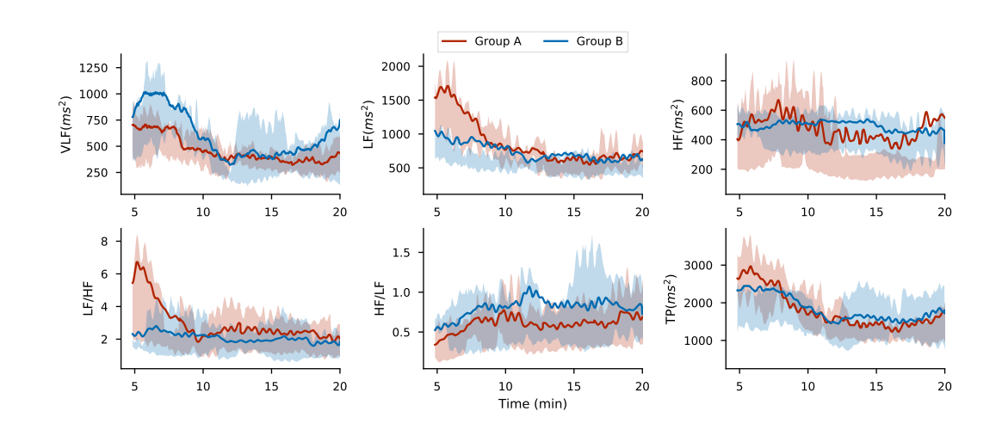
Figure 1: Comparison of spectra HRV between subjects in groups A and B. The solid line indicates the mean values while the shaded area represents the data variation ranges (expressed in terms of the 1st and 3rd quartile). Subjects in group A exhibit a higher sympathetic activity (high LF) while those in group B have a higher stress recovery component (higher VLF)

We must note that we did all analyses on one specific dataset, the SWELL dataset. Our results may be dependent on the specific characteristics of this dataset. We separated our data into two parts (train & test data) and then analyzed this data.

In train data, we calculated values for each condition (no stress, interruption, time pressure) (Fig. 2).
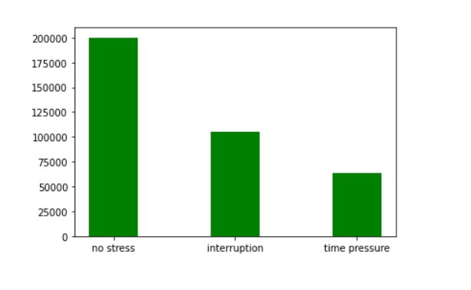
Figure 2: Comparison between no stress, interruption and time pressure

Here, we calculated the relationship of each column to the other and displayed the result using a heatmap (Fig. 3).

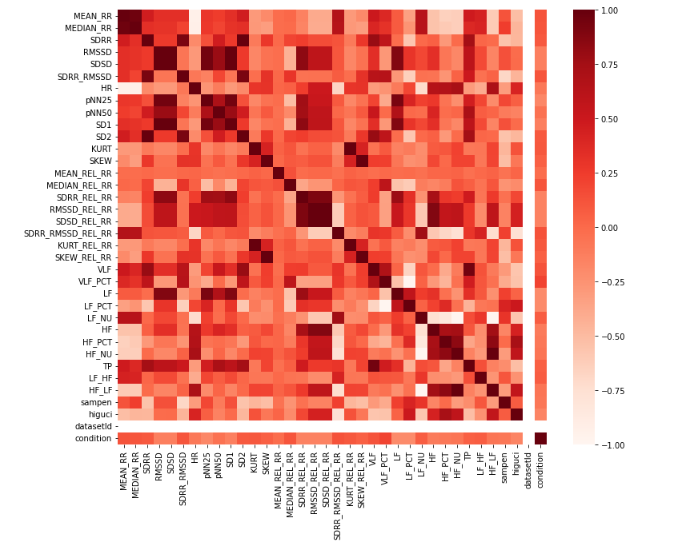
Figure 3: this displayed the relationship of each column to the other

Then we calculated the mean heart rate and median heart rate and compared them to the real values(Fig. 4).

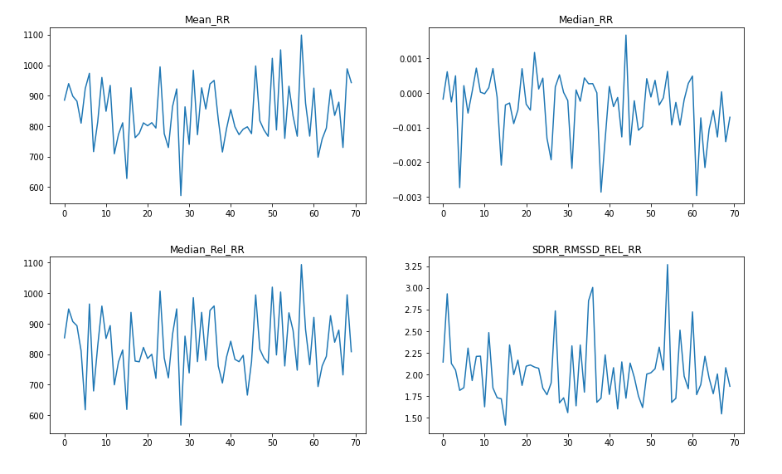
Figure 4

We will notice the strong similarity between mean heart rate and median heart rate(Fig. 5).

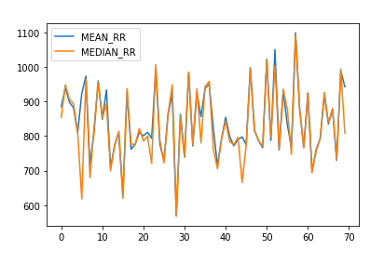
Figure 5

We did a classification report for 4 algorithms(Fig. 6,7,8,9).
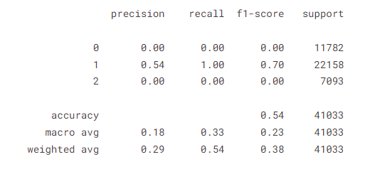
Figure 6: ANN

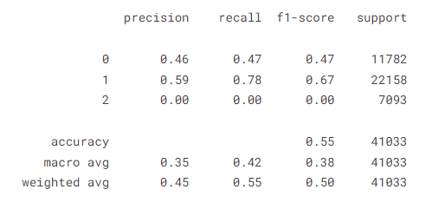
Figure 7: perceptron

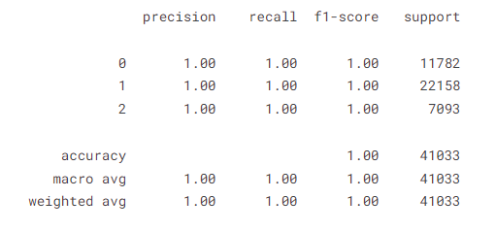
Figure 8: Random Forest

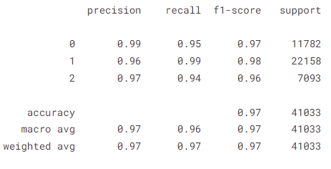
Figure 9: Decision Tree

We will notify the convergence between the random forest and decision tree so we calculate the correlation between each condition to the other in each algorithm(Fig. 10).

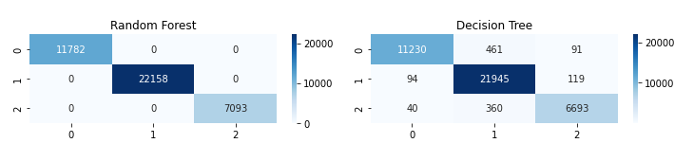
Figure 10: 1 = no stress, 2 = time pressure, 0 = interruption

We find that random forest is the best algorithm.

GENOTYPE
Past studies have found that glucocorticoids alter gene expression in the brain. The researchers added corticosterone—the major hormone that mice produce in stressful situations—to their drinking water for 4 weeks. After exposure, and again after a 4-week recovery period without corticosterone, the scientists tested the mice for behavioral and physiological changes. They examined the expression levels of 5 HPA axis genes in the hippocampus, hypothalamus and blood. They also tested the genes' methylation levels—a common epigenetic modification that affects gene expression.
The CORT mice also exhibited anxiety-like behaviour in the EPM test(Fig.11), spending more time in the closed arms compared with control mice (Fig. 12A​). This difference in the EPM test also diminished to near control levels once the CORT-treated mice were allowed 4 wk of recovery (Fig. 12B​). On the other hand, no behavioural differences were observed between CORT and control mice in the tail suspension test after 4 wk of corticosterone treatment (Fig. 12C) nor after the 4-wk recovery period (Fig. 12D​).

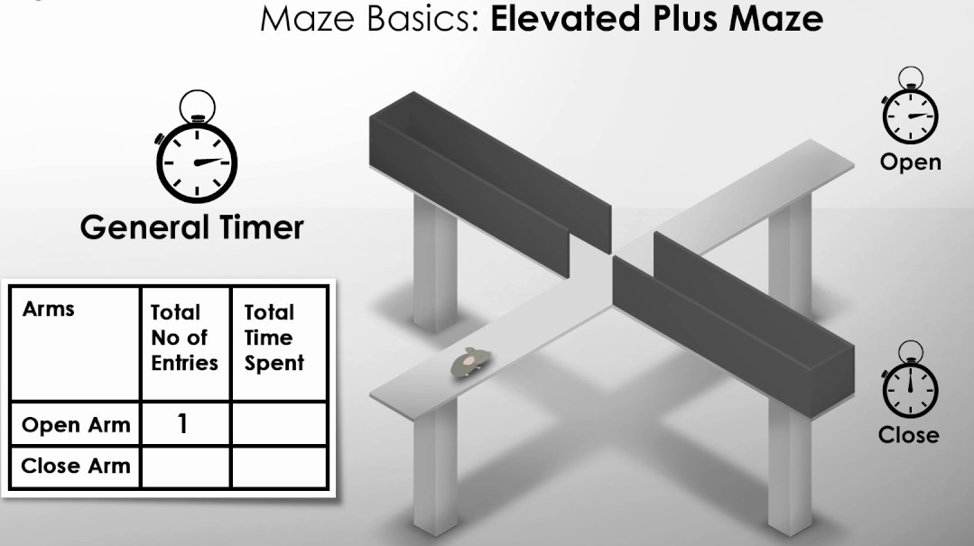
Figure 11: The EPM Test

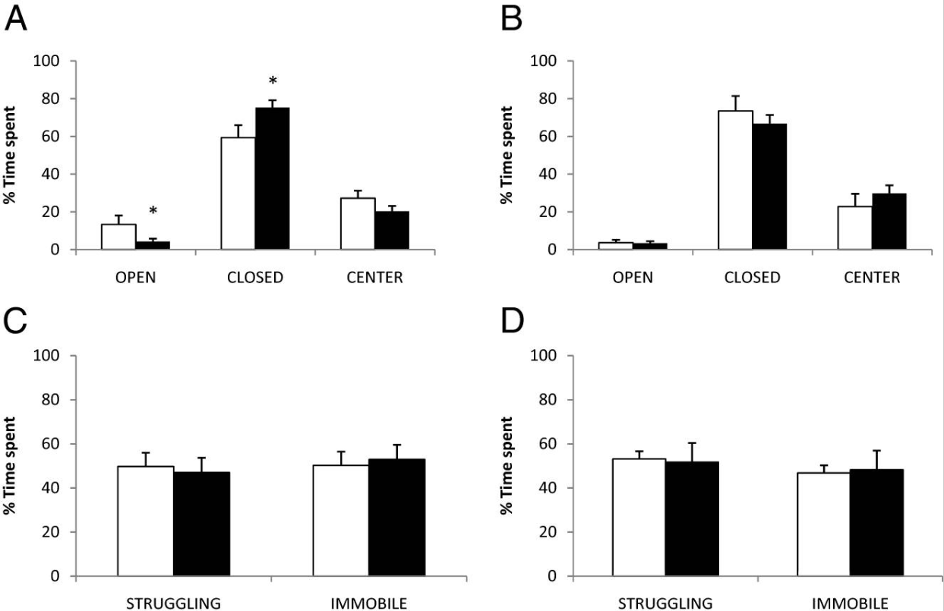
(Fig. 12) Mice were challenged with the elevated plus maze (EPM) and tail suspension test (TST) to test for anxiety-like and depressive-like symptoms, respectively. EPM: After 4 weeks of treatment (A), corticosterone (black bars) and vehicle-treated (white bars) animals were each tested for a 10-min period, and the amount of time spent in each of the open arms (OPEN), closed arms (CLOSED), and the centre (CENTER) is displayed as a percentage of the total time spent (10 min) on the apparatus. The same measurements were made after the 4-week recovery period (B). TST: After 4 weeks of treatment (C), corticosterone (black bars) and vehicle-treated (white bars) animals were tested for a 6-min period, and the amount of time spent struggling (STRUGGLING) or immobile (IMMOBILE) is displayed as a percentage of the total time spent (6 min) on the suspension apparatus. The same measurements were made after the 4-week recovery period (D).

The researchers reported that mice given corticosterone appeared more anxious during a maze test. Chronic exposure to corticosterone altered the expression of 3 HPA axis genes, including higher levels of Fkbp5 in the hippocampus, hypothalamus, and blood (Fig. 13). The protein that Fkbp5 codes for is part of a molecular complex that interacts with the glucocorticoid receptor. In addition, the researchers found decreased Fkbp5 methylation levels in the mice exposed to corticosterone.
The researchers reported that mice given corticosterone appeared more anxious during a maze test. Chronic exposure to corticosterone altered the expression of 3 HPA axis genes, including higher levels of Fkbp5 in the hippocampus, hypothalamus, and blood. The protein that Fkbp5 codes for is part of a molecular complex that interacts with the glucocorticoid receptor. In addition, the researchers found decreased Fkbp5 methylation levels in the mice exposed to corticosterone.

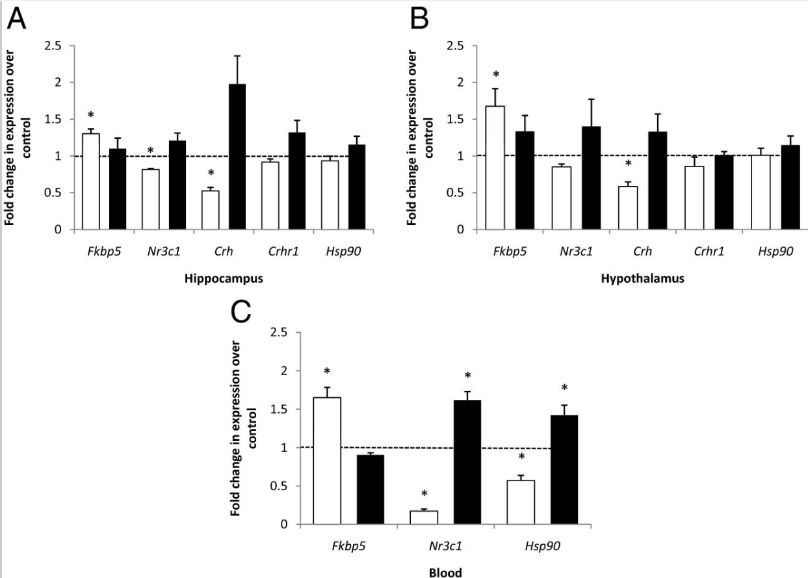
(Fig. 13) Genetic variations in Fkbp5 have been associated with posttraumatic stress disorder and mood disorders, which are characterized by abnormal glucocorticoid regulation. These results suggest that methylation of Fkbp5 may play a role in mediating the effects of glucocorticoids on behaviour.

The epigenetic impacts of early-life stress
A wide range of animal models of early-life adversity has been established in multiple species, revealing a consistent and enduring impact of pre-and post-natal stress, as well as reduced maternal care, on offspring development and behaviour, including the risk of psychopathology [61-63]. Classic experiments with rodents demonstrated that the offspring of mothers providing relatively low levels of postnatal maternal care exhibited increased stress-reactivity, anxiety, and fearfulness, in comparison to the offspring of mothers displaying normal levels of caregiving [40]. Experimentally induced maternal separation and stress also led to increased stress-reactivity, anxiety, depressive-like symptoms, and impaired social interactions, in offspring deprived of maternal care, along with genome-wide alterations in patterns of DNA methylation and neuronal gene transcription in the brain [64, 65].
Research in humans has confirmed and extended the findings of animal experiments on the effects of early-life stress [65]. Overall, the evidence indicates that fetal gestation, infancy, and childhood are sensitive periods during which exposure to social adversity can induce behavioural, psychological, and epigenetic changes that may persist into adulthood. A recent systematic review identified 40 articles published between 2004 and 2014, describing studies of NR3C1 methylation changes in response to early-life adversity, parental stress, and psychopathology, of which 27 were studies in humans [66]. A range of experiences highly likely to induce prenatal stress, such as intimate partner violence [67], or maternal exposure to genocidal war [68] was associated with increased NR3C1 promoter methylation. Moreover, childhood abuse, neglect, and deprivation were also found to be associated with increased NR3C1 promoter methylation [23, 69-71]. More recent reports provide additional support for a relationship between early-life adversity, increased promoter methylation, and decreased transcription of NR3C1 [65, 71, 72]. These varied studies suggest that attenuation of NR3C1 expression is a component of the process leading to the elevation of HPA axis activity, as a consequence of allostatic overload induced by a variety of stressful experiences.

Table 1. Examples of differentially methylated genes associated with social stress.
Stressor | Species | Genes
Early-life stress | Mouse | Avp, Nr3c1, Prkcc
Early-life stress | Rat | Bdnf, Nr3c1, Pcdh
Early-life stress | Macaque  monkey | NR3C1, MMP7, RALB, CYP7A1, CLEC9, XM_001092634.1, KIAA1671, ST6GALNAC1, MTTP, APEX2, INTS7, TRAK1, TTC35, ZNF724P, ZG16, MORC1
Early-life stress | Human | NR3C1, MAOA, CRH, CRHBP, FKBP5, GAS5, miR-124, LGI1/LGI2, MORC1, BDNF, SLC6A4, KITLG, PM20D1, SLC17A3, PCDH

Trauma, post-traumatic stress disorder & intergenerational inheritance of stress disorders
The intense stress resulting from exposure to traumatic experiences such as war, famine or genocide, increases the risk of mental health disorders, including post-traumatic stress disorder (PTSD), depression, schizophrenia and suicide. Trauma can exert long-term psychosocial and epigenetic impacts when experienced during early life, as was first demonstrated by the specific association between NR3C1 hypermethylation in postmortem brain samples of suicide completers with a history of child abuse [23, 69].
Further evidence of intergenerational transmission of behaviours that are epigenetically mediated has emerged from experimental studies with rodents subjected to handling stress and deprived of maternal care. The Maternal Separation combined with Unpredictable Stress (MSUS) paradigm has demonstrated that postnatal trauma caused by reduced quality and quantity of maternal care causes mice to develop into adulthood with elevated depressive behaviours and reduced behavioural control in response to stressful stimuli, phenotypes which can be transmitted to two subsequent generations without further exposure of newborn pups to reduced maternal care [73]. In addition, sperm from traumatized males contained trauma-induced miRNAs, and microinjection of purified RNA extracted from the sperm of these traumatized adult males recapitulated aspects of MSUS-induced behavioural abnormalities[74].
Animal models of postnatal trauma exhibit behavioural abnormalities that are accompanied by specific variations in DNA methylation patterns within the brain. Intergenerational transmission of trauma-induced behavioural abnormalities is linked to variation in sperm DNA methylation patterns and miRNA content.

In summary, we tested the hypothesis that expression changes would be induced in HPA axis genes by differential, chronic exposure to corticosterone and that these changes would occur through loss or gain of DNAm. Low levels of postnatal maternal care in a range of experimental animal species increase DNA methylation and attenuate transcription at Nr3c1, Avp, and Bdnf loci in offspring CNS, while increasing anxiety, depressive symptoms, and stress reactivity. Exposure of human offspring to distinct forms of social adversity during fetal gestation, infancy, and childhood can induce behavioural, psychological, and DNA methylation changes. Chronic social defeat is observed with an associated decrease in the expression of NR3C1, BDNF, and SLC6A4. NR3C1 encodes the glucocorticoid receptor (GR), and decreased expression at this locus is associated with reduced GR expression, leading to hyperactivity of the hypothalamic-pituitary-adrenal (HPA) axis. Trauma, post-traumatic stress disorder and suicide are associated with variable DNA methylation at loci such as NR3C1, SKA2 and FKBP5.

CONCLUSION
Though the study of the interactions between the stress axis and the epigenome remains in its early stages, its promise is already evident. that stressful interactions with the environment induce regionally and developmentally specific changes in our behaviour. Traumatic experiences in our past—and in our ancestors’ past—can scar our DNA. Although we can inherit stress-induced genetic expressions, we can also reverse this process. With particular lifestyle and environmental changes, you can reduce your stress and reset your genetics for a healthier one. this paper show that epigenetic mechanisms are strongly involved in the stress response in the central nervous system. Found that chronic psychogenic stress paradigms can influence epigenetic patterns of approximately 2000 genes. Relatively few epigenetic studies have been conducted in the area of stress until now. we still know very little about the epigenetic effects of stress.
Moreover, as a consequence of a small number of publications studying a vast number of epigenetic mechanisms, only a handful of results were replicated. There is also a need for more data concerning which stress mediators and biochemical pathways are responsible for epigenetic changes during stress. Although this topic is still only emerging, there are already a few interesting conclusions that can be drawn from existing data.

Acknowledgment
In the name of Allah, the beneficent, the merciful
First of all, praises to Allah, the almighty, for giving me the power and will to complete this paper and present it proudly.
Next, I would like to express my gratitude and thanks to my supervisor Prof. Dr. Taysir Hassan A Soliman dean of Faculty of Computer Science and Information, Assiut University, for constructive guidance and insightful comments throughout this thesis which added a lot to our experience as a researcher.

References
1. Dhabhar, F.S., The short-term stress response - Mother nature's mechanism for enhancing protection and performance under conditions of threat, challenge, and opportunity. Front Neuroendocrinol, 2018. 49: p. 175-192.
2. GAPIN, T.B., MALE 2.0. 2020.
3. Dhabhar, F.S. and B.S. McEwen, Stress-induced enhancement of antigen-specific cell-mediated immunity. The Journal of Immunology, 1996. 156(7): p. 2608-2615.
4. Dhabhar, F.S., et al., Diurnal and acute stress-induced changes in distribution of peripheral blood leukocyte subpopulations. Brain, behavior, and immunity, 1994. 8(1): p. 66-79.
5. Dhabhar, F.S., Effects of stress on immune function: the good, the bad, and the beautiful. Immunologic research, 2014. 58(2): p. 193-210.
6. Dhabhar, F.S., et al., Effects of stress on immune cell distribution. Dynamics and hormonal mechanisms. The Journal of Immunology, 1995. 154(10): p. 5511-5527.
7. Altemus, M., M. Cloitre, and F.S. Dhabhar, Enhanced cellular immune response in women with PTSD related to childhood abuse. American Journal of Psychiatry, 2003. 160(9): p. 1705-1707.
8. Henry, J.P., Biological basis of the stress response. Integrative physiological and behavioral science, 1992. 27(1): p. 66-83.
9. Von Holst, D., The concept of stress and its relevance for animal behavior. 1998.
10. Smith, G.D., et al., Cortisol, Testosterone, and Coronary Heart Disease. Circulation, 2005. 112(3): p. 332-340.
11. Weinhold, B., Epigenetics: the science of change. Environ Health Perspect, 2006. 114(3): p. A160-7.
12. El-Osta, A. and A.P. Wolffe, DNA methylation and histone deacetylation in the control of gene expression: basic biochemistry to human development and disease. Gene Expr, 2000. 9(1-2): p. 63-75.
13. Rose, N.R. and R.J. Klose, Understanding the relationship between DNA methylation and histone lysine methylation. Biochimica et Biophysica Acta (BBA)-Gene Regulatory Mechanisms, 2014. 1839(12): p. 1362-1372.
14. Kondo, Y., Epigenetic cross-talk between DNA methylation and histone modifications in human cancers. Yonsei medical journal, 2009. 50(4): p. 455-463.
15. Vidrascu, E.M., et al., Effects of early-and mid-life stress on DNA methylation of genes associated with subclinical cardiovascular disease and cognitive impairment: a systematic review. BMC medical genetics, 2019. 20(1): p. 1-12.
16. Niwa, M., et al., Adolescent Stress&#x2013;Induced Epigenetic Control of Dopaminergic Neurons via Glucocorticoids. Science, 2013. 339(6117): p. 335-339.
17. Zannas, A.S., et al., Gene–stress–epigenetic regulation of FKBP5: clinical and translational implications. Neuropsychopharmacology, 2016. 41(1): p. 261-274.
18. Association, A.P., APA Thesaurus of Psychological Index Terms. 2020.
19. Alegría-Torres, J.A., A. Baccarelli, and V. Bollati, Epigenetics and lifestyle. Epigenomics, 2011. 3(3): p. 267-77.
20. Kivimaki, M., et al., Consortium, IP-W., 2015. Long working hours and risk of coronary heart disease and stroke: a systematic review and meta-analysis of published and unpublished data for 603,838 individuals. Lancet. 386(10005): p. 1739-1746.
21. Steptoe, A. and M. Kivimäki, Stress and cardiovascular disease: an update on current knowledge. Annual review of public health, 2013. 34: p. 337-354.
22. Palma-Gudiel, H., et al., Glucocorticoid receptor gene (NR3C1) methylation processes as mediators of early adversity in stress-related disorders causality: a critical review. Neuroscience & Biobehavioral Reviews, 2015. 55: p. 520-535.
23. McGowan, P.O., et al., Epigenetic regulation of the glucocorticoid receptor in human brain associates with childhood abuse. Nature neuroscience, 2009. 12(3): p. 342-348.
24. Yao, B., et al., DNA N6-methyladenine is dynamically regulated in the mouse brain following environmental stress. Nature communications, 2017. 8(1): p. 1-10.
25. Wang, F., et al., Early Life Stress-Induced Epigenetic Changes Involved in Mental Disorders. Frontiers in Genetics, 2021: p. 1010.
26. Wazana, A., E. Székely, and T.F. Oberlander, Prenatal Stress and Child Development. 2021: Springer.
27. Stoffel, M., et al., Evaluation of stress management and stress prevention using epigenetic markers. Verhaltenstherapie, 2020: p. 1-9.
28. Koldijk, S., et al. The swell knowledge work dataset for stress and user modeling research. in Proceedings of the 16th international conference on multimodal interaction. 2014.
29. Mizuno, K. and Y. Watanabe, Neurocognitive impairment in childhood chronic fatigue syndrome. Frontiers in Physiology, 2013. 4: p. 87.
30. Nkurikiyeyezu, K., et al. Thermal Comfort and Stress Recognition in Office Environment. in HEALTHINF. 2019.
31. Koldijk, S., M.A. Neerincx, and W. Kraaij, Detecting work stress in offices by combining unobtrusive sensors. IEEE Transactions on affective computing, 2016. 9(2): p. 227-239.
32. Hart, S.G. and L.E. Staveland, Development of NASA-TLX (Task Load Index): Results of empirical and theoretical research, in Advances in psychology. 1988, Elsevier. p. 139-183.
33. Lin, Y., W. Zhang, and L.G. Watson, Using eye movement parameters for evaluating human–machine interface frameworks under normal control operation and fault detection situations. International Journal of Human-Computer Studies, 2003. 59(6): p. 837-873.
34. Bradley, M.M. and P.J. Lang, Measuring emotion: the self-assessment manikin and the semantic differential. Journal of behavior therapy and experimental psychiatry, 1994. 25(1): p. 49-59.
35. Koldijk, S., et al. Unobtrusive monitoring of knowledge workers for stress self-regulation. in International Conference on User Modeling, Adaptation, and Personalization. 2013. Springer.
36. Border, R., et al., No support for historical candidate gene or candidate gene-by-interaction hypotheses for major depression across multiple large samples. American Journal of Psychiatry, 2019. 176(5): p. 376-387.
37. Zannas, A.S. and A.E. West, Epigenetics and the regulation of stress vulnerability and resilience. Neuroscience, 2014. 264: p. 157-170.
38. Wu, C.-T. and J.R. Morris, Genes, genetics, and epigenetics: a correspondence. Science, 2001. 293(5532): p. 1103-1105.
39. Schuebel, K., et al., Making sense of epigenetics. International Journal of Neuropsychopharmacology, 2016. 19(11): p. pyw058.
40. Weaver, I.C., et al., Epigenetic programming by maternal behavior. Nature neuroscience, 2004. 7(8): p. 847-854.
41. Lester, B.M., et al., Behavioral epigenetics. Annals of the New York Academy of Sciences, 2011. 1226(1): p. 14-33.
42. Provenzi, L., E. Guida, and R. Montirosso, Preterm behavioral epigenetics: A systematic review. Neuroscience & Biobehavioral Reviews, 2018. 84: p. 262-271.
43. Jiang, S., et al., Epigenetic modifications in stress response genes associated with childhood trauma. Frontiers in psychiatry, 2019. 10: p. 808.
44. Vaiserman, A.M., Epigenetic programming by early‐life stress: Evidence from human populations. Developmental Dynamics, 2015. 244(3): p. 254-265.
45. Pérez, R.F., et al., Longitudinal genome-wide DNA methylation analysis uncovers persistent early-life DNA methylation changes. Journal of translational medicine, 2019. 17(1): p. 1-16.
46. Sweatt, J.D., Experience-dependent epigenetic modifications in the central nervous system. Biological psychiatry, 2009. 65(3): p. 191-197.
47. Feng, J., et al., Dnmt1 and Dnmt3a maintain DNA methylation and regulate synaptic function in adult forebrain neurons. Nature neuroscience, 2010. 13(4): p. 423-430.
48. Siegmund, K.D., et al., DNA methylation in the human cerebral cortex is dynamically regulated throughout the life span and involves differentiated neurons. PloS one, 2007. 2(9): p. e895.
49. Bakusic, J., et al., Stress, burnout and depression: A systematic review on DNA methylation mechanisms. Journal of psychosomatic research, 2017. 92: p. 34-44.
50. Heyward, F.D. and J.D. Sweatt, DNA methylation in memory formation: emerging insights. The Neuroscientist, 2015. 21(5): p. 475-489.
51. Oliveira, A.M., T.J. Hemstedt, and H. Bading, Rescue of aging-associated decline in Dnmt3a2 expression restores cognitive abilities. Nature neuroscience, 2012. 15(8): p. 1111-1113.
52. LaPlant, Q., et al., Dnmt3a regulates emotional behavior and spine plasticity in the nucleus accumbens. Nature neuroscience, 2010. 13(9): p. 1137-1143.
53. Miller, C.A. and J.D. Sweatt, Covalent modification of DNA regulates memory formation. Neuron, 2007. 53(6): p. 857-869.
54. Rodrigues Jr, G.M., et al., Acute stress affects the global DNA methylation profile in rat brain: modulation by physical exercise. Behavioural brain research, 2015. 279: p. 123-128.
55. Mifsud, K.R., et al., Rapid down-regulation of glucocorticoid receptor gene expression in the dentate gyrus after acute stress in vivo: role of DNA methylation and microRNA activity. Neuroendocrinology, 2017. 104(2): p. 157-169.
56. Elliott, E., et al., Resilience to social stress coincides with functional DNA methylation of the Crf gene in adult mice. Nature neuroscience, 2010. 13(11): p. 1351-1353.
57. Unternaehrer, E., et al., Dynamic changes in DNA methylation of stress-associated genes (OXTR, BDNF) after acute psychosocial stress. Translational psychiatry, 2012. 2(8): p. e150-e150.
58. Ziegler, C., et al., Oxytocin receptor gene methylation: converging multilevel evidence for a role in social anxiety. Neuropsychopharmacology, 2015. 40(6): p. 1528-1538.
59. Nikolova, Y.S. and A.R. Hariri, Can we observe epigenetic effects on human brain function? Trends in cognitive sciences, 2015. 19(7): p. 366-373.
60. Lee, R.S., et al., Chronic corticosterone exposure increases expression and decreases deoxyribonucleic acid methylation of Fkbp5 in mice. Endocrinology, 2010. 151(9): p. 4332-4343.
61. Anacker, C., K.J. O'Donnell, and M.J. Meaney, Early life adversity and the epigenetic programming of hypothalamic-pituitary-adrenal function. Dialogues in clinical neuroscience, 2022.
62. Maccari, S., et al., The consequences of early‐life adversity: neurobiological, behavioural and epigenetic adaptations. Journal of neuroendocrinology, 2014. 26(10): p. 707-723.
63. Kundakovic, M. and F.A. Champagne, Early-life experience, epigenetics, and the developing brain. Neuropsychopharmacology, 2015. 40(1): p. 141-153.
64. Murgatroyd, C., et al., Dynamic DNA methylation programs persistent adverse effects of early-life stress. Nature neuroscience, 2009. 12(12): p. 1559-1566.
65. Cunliffe, V.T., The epigenetic impacts of social stress: how does social adversity become biologically embedded? Epigenomics, 2016. 8(12): p. 1653-1669.
66. Turecki, G. and M.J. Meaney, Effects of the Social Environment and Stress on Glucocorticoid Receptor Gene Methylation: A Systematic Review. Biological Psychiatry, 2016. 79(2): p. 87-96.
67. Radtke, K.M., et al., Transgenerational impact of intimate partner violence on methylation in the promoter of the glucocorticoid receptor. Translational Psychiatry, 2011. 1(7): p. e21-e21.
68. Mulligan, C., et al., Methylation changes at NR3C1 in newborns associate with maternal prenatal stress exposure and newborn birth weight. Epigenetics, 2012. 7(8): p. 853-857.
69. Labonte, B., et al., Differential Glucocorticoid Receptor Exon 1B, 1C, and 1H Expression and Methylation in Suicide Completers with a History of Childhood Abuse. Biological Psychiatry, 2012. 72(1): p. 41-48.
70. Weder, N., et al., Child Abuse, Depression, and Methylation in Genes Involved With Stress, Neural Plasticity, and Brain Circuitry. Journal of the American Academy of Child & Adolescent Psychiatry, 2014. 53(4): p. 417-424.e5.
71. Tyrka, A.R., et al., Methylation of exons 1D, 1F, and 1H of the glucocorticoid receptor gene promoter and exposure to adversity in preschool-aged children. Development and Psychopathology, 2015. 27(2): p. 577-585.
72. van der Knaap, L.J., et al., Glucocorticoid receptor gene (NR3C1) methylation following stressful events between birth and adolescence. The TRAILS study. Translational Psychiatry, 2014. 4(4): p. e381-e381.
73. Franklin, T.B., et al., Epigenetic Transmission of the Impact of Early Stress Across Generations. Biological Psychiatry, 2010. 68(5): p. 408-415.
74. Gapp, K., et al., Implication of sperm RNAs in transgenerational inheritance of the effects of early trauma in mice. Nature Neuroscience, 2014. 17(5): p. 667-669.
IEEE conference templates contain guidance text for composing and formatting conference papers. Please ensure that all template text is removed from your conference paper prior to submission to the conference. Failure to remove template text from your paper may result in your paper not being published.

